HOMEWORK ASSIGNMENT
Week 5
45 Points Maximum

Name ______________________________________
NETW204
Homework #5
Due Date _____________________________________

Professor ______________________________________

OSPF

- Given the diagram below and OSPF properly configured on routers 1 and 2. The network engineer typed two Cisco IOS commands in the Command Line Interface (CLI) back to back and observed the output below.
Explain how the cost to the 192.168.1.0/24 route was calculated in OSPF. (15 points)

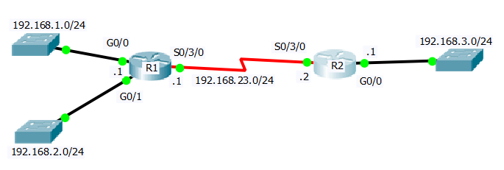

R2#show ip route
Codes: L - local, C - connected, S - static, R - RIP, M - mobile, B - BGP
D - EIGRP, EX - EIGRP external, O - OSPF, IA - OSPF inter area
i - IS-IS, L1 - IS-IS level-1, L2 - IS-IS level-2, ia - IS-IS inter area
* - candidate default,

O 192.168.1.0/24 [110/65] via 192.168.23.1, 00:03:44, Serial0/3/0
O 192.168.2.0/24 [110/65] via 192.168.23.1, 00:03:44, Serial0/3/0
192.168.3.0/24 is variably subnetted, 2 subnets, 2 masks
C 192.168.3.0/24 is directly connected, GigabitEthernet0/0
192.168.23.0/24 is variably subnetted, 2 subnets, 2 masks
C 192.168.23.0/24 is directly connected, Serial0/3/0
!
! Removal of unnecessary lines.
R2#show interface s0/3/0
Serial0/3/0 is up, line protocol is up (connected)
Hardware is HD64570
Internet address is 192.168.23.2/24
MTU 1500 bytes, BW 1544 Kbit, DLY 20000 usec,
reliability 255/255, txload 1/255, rxload 1/255
Encapsulation HDLC, loopback not set, keepalive set (10 sec)
!
! Removal of unnecessary lines.
R2#

- Explain the steps that two routers take to become fully adjacent neighbors in OSPF. (15 Points)

- Explain the difference between DR, BDR, and DROTHER. How would you go about changing the BDR to DR assuming all the routers are up and operational (nothing went down)? What would be the impact of such a change on a live or production network? (15 points)

